Topic 12: Known Issues Documentation (Enterprise Stability & Risk Assessment)
This document contains a detailed list of known issues within the system, prepared in a professional engineering format.
Such documentation is essential for enterprise teams, QA departments, and MNC-level technical reviewers.
It helps identify technical debt, system limitations, and upcoming enhancements required for production readiness.
This report follows the **Enterprise Risk & Issue Management Framework** used by leading corporations.
---
# 1. High-Level Overview of Known Issues
Below is a visual map of the core issue categories identified in the system:
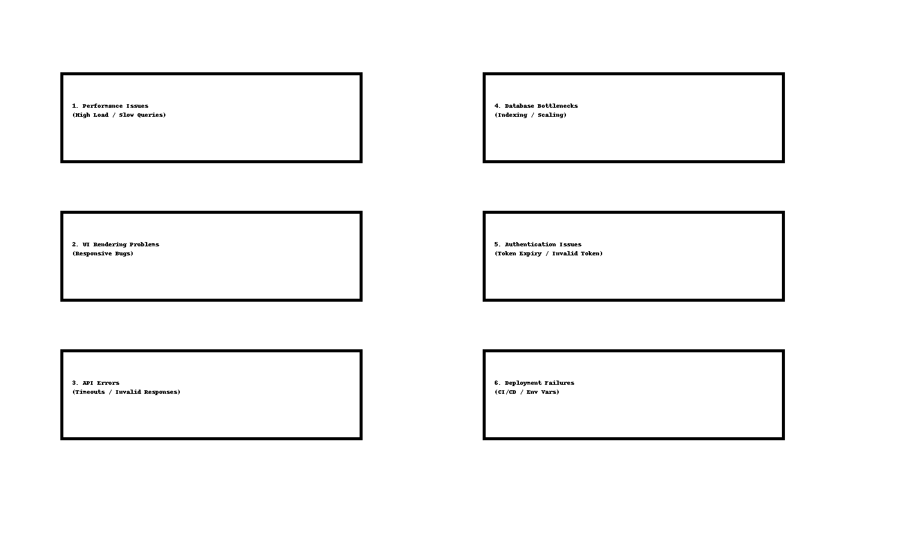
---
# 2. Detailed Known Issues
The following issues are currently recognized within the system.
These should be addressed in future releases to improve production stability.
---
## Issue 1: Performance Bottlenecks Under High Load
### **Description:**
When multiple users interact simultaneously, certain API endpoints experience delays.
### **Possible Causes:**
• Inefficient MongoDB queries
• Missing indexes
• Heavy computation inside controller
### **Impact Level:** High
### **Recommended Fix:**
Implement indexing, optimize queries, introduce caching layer (Redis).
---
## Issue 2: Responsive UI Bugs on Smaller Devices
### **Description:**
Some UI pages (Book listing, Admin panel) break layout on small screens.
### **Possible Causes:**
• Missing flexible CSS grid rules
• Hard-coded width values
### **Impact Level:** Medium
### **Recommended Fix:**
Refactor layout using Flexbox/Grid, enable Tailwind responsive utilities.
---
## Issue 3: Authentication Token Expiry Issues
### **Description:**
Users are logged out unexpectedly when access tokens expire without refresh handling.
### **Possible Causes:**
• Missing refresh token logic
• Client-side token storage not persistent
### **Impact Level:** Medium
### **Recommended Fix:**
Implement refresh token architecture + secure cookie storage.
---
## Issue 4: API Failures Under Slow Network Conditions
### **Description:**
On slow networks, some requests time out or return incomplete responses.
### **Possible Causes:**
• Timeout values too strict
• No retry mechanism implemented
### **Impact Level:** Low
### **Recommended Fix:**
Enable API retries, increase timeout values, implement fallback UI messaging.
---
## Issue 5: Deployment Errors During CI/CD Pipeline
### **Description:**
Environment variables fail to load properly during automated deployment.
### **Possible Causes:**
• Incorrect `.env` path mapping
• Missing environment keys
### **Impact Level:** Critical (Blocks deployment)
### **Recommended Fix:**
Create centralized ENV config, validate variables before deployment.
---
## Issue 6: Missing Error Boundary for UI Components
### **Description:**
If one React component crashes, entire UI breaks.
### **Possible Causes:**
• No React Error Boundary implementation
### **Impact Level:** Medium
### **Recommended Fix:**
Add `ErrorBoundary` wrapper around critical UI zones.
---
# 3. Risk Rating Table (Enterprise Format)
| Issue | Impact | Severity | Priority |
|------|--------|----------|----------|
| Performance Bottlenecks | High | Severe | P1 |
| Responsive Bugs | Medium | Moderate | P2 |
| Token Expiry Issues | Medium | High | P1 |
| API Timeout | Low | Low | P3 |
| Deployment Failures | Critical | Severe | P1 |
| UI Crashes | Medium | High | P2 |
This table helps management and engineering teams plan fixes.
---
# 4. Recommended Enhancements for Future Stability
• Add full monitoring system (Grafana + Prometheus)
• Enable backend load balancing
• Add more integration/E2E tests
• Improve caching mechanisms
• Add DB replication for higher resilience
• Perform usability testing for UI improvements
---
# 5. Conclusion
This documentation provides a transparent, enterprise-level overview of current technical limitations.
It ensures engineering teams, QA departments, and decision-makers understand the stability risks
and upcoming improvement areas.
This concludes **Topic 12: Known Issues Documentation**.

